Warm Up

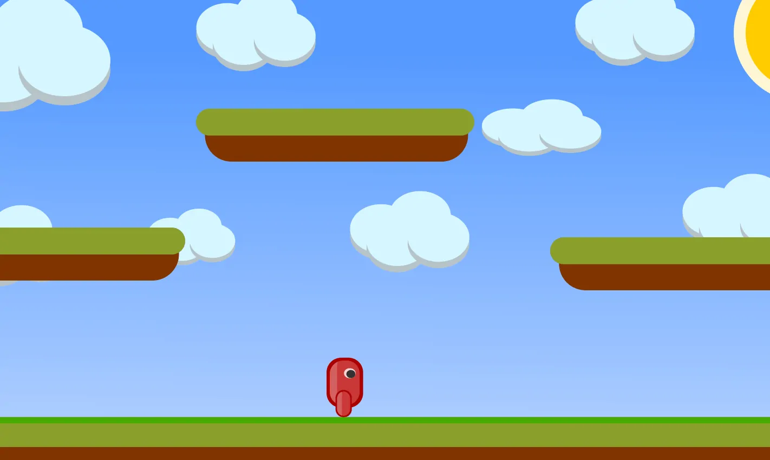

Identify different elements in the scene and explain how they might be implemented using nodes.